Key Information & Policies

Important Information

Contact details

Emma Whitworth - Head of Pre-employment Training

Email: emma@b2wgroup.com

Mobile: 07973 950559

Alison Dann – Designated Safeguarding Lead

Email: safeguarding@b2wgroup.com

Mobile: 07966 275725

Key Roles

The Inductor: Your Inductor will provide initial advice and guidance, establish what you already know and conduct an initial assessment to help identify any needs you might like help with. Here you will begin the learner journey and ensure the flexible learning process is understood.

In addition to the above the Inductor will give you step-by-step guidance through the sign-up paperwork and they will issue your learning materials and give guidance on how to complete the course. They will then take you through this handbook and confirm all of the support we will oﬀer to help you succeed, enabling you to engage with the learning materials to ensure you are comfortable with all expectations.

Learner: You need to produce work each day on your course that will then be marked by the trainer and you will receive ongoing feedback throughout your study manual.

Trainer: It is their role to encourage you to set self-stretching targets. They are at hand to provide support and guidance where required. They will always produce robust written feedback on progression of assessments throughout the course.

Internal Quality Assurance Representative: An internal quality assurance representative will quality check your work to ensure it has been accurately and fairly assessed by your trainer.

External Quality Assurance Representative: The awarding body’s external quality assurance representative will check that we are working fairly and to the specified standards. They will audit your work before allowing us to award a certificate.

Completion: After internal and external quality assurance, B2W Complete Training will send your e-certificate directly to the email you have provided. If you change your email address, you must let B2W Complete Training know in order for you to receive your certificate, we do not issue paper copies, these can be requested directly from the awarding body at an additional cost to yourself.
English and Maths
Having a strong grounding in maths and English is vital for people in today’s job market. These subjects act as basic filters for employers. Employers talk of an alarming gap between the literacy and numeracy skills they require and the skills that job applicants possess.
At induction, you will complete initial assessments in English and maths. This will inform your trainer of the current level you are working at and also aides planning for learning to ensure you make good progress in these core skills.
At Back 2 Work we aim to help you develop these skills throughout your course by embedding elements of maths and English in the activities that you will complete.
As part of the feedback on your work the following annotations will give you guidance on areas that you can strengthen.
Remember to proofread your work for grammatical and spelling errors and that you are writing in full sentences that clearly articulate what you want to say.
Good luck and we hope you enjoy your course!
Spelling and Grammar Annotations Key
Annotation | What it refers to
Sp | Spelling error – this could include incorrect use of homophones e.g. to, too and two.
P | Punctuation error – Could be incorrect use or missing.
G | Grammatical error – Wrong tense used, or sentences are incomplete.
// | New paragraph needed (inserted where new paragraph should begin)
C | Colloquialism – Writing as you speak, too informal. Also, where slang is being used.
Cap | Misuse of capital letter – Using one where it is not needed or forgetting to use one where it is required.
^ | Missing word

Feedback for English
Feedback will be provided to help improve your skills by applying the key above to your work. We want to support you and, with this in mind, there will be key points within your study manual, for which, your trainer will provide guidance. Your trainer will identify any areas of development and will guide you so that you can improve further. The marking scheme will be applied at 3 key stages throughout your portfolio and this will enable you to see the distance travelled with improving your English skills. This will help prepare you for your next steps with employment.
Stage 1 | Feedback for English will be given after you have fully completed section 1 of your work booklet. This will be used as a further initial assessment tool and the feedback you receive can be used to support and improve your further written work. The trainer will identify key common errors and support you to be able to work on these moving forward with your written work.
Stage 2 | Halfway through your programme your trainer will again provide feedback on your English skills to measure the distance you will have travelled based on the feedback provided at stage 1 of your portfolio.
Stage 3 | You have now completed all of your programme study manual and you will receive final feedback and support with regards to your English skills.
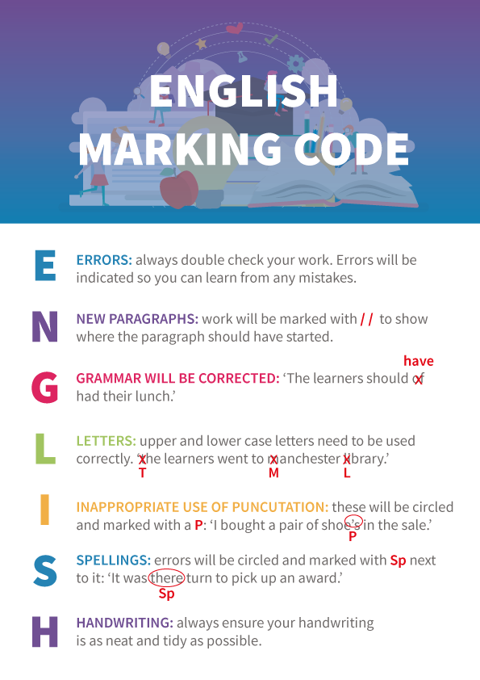
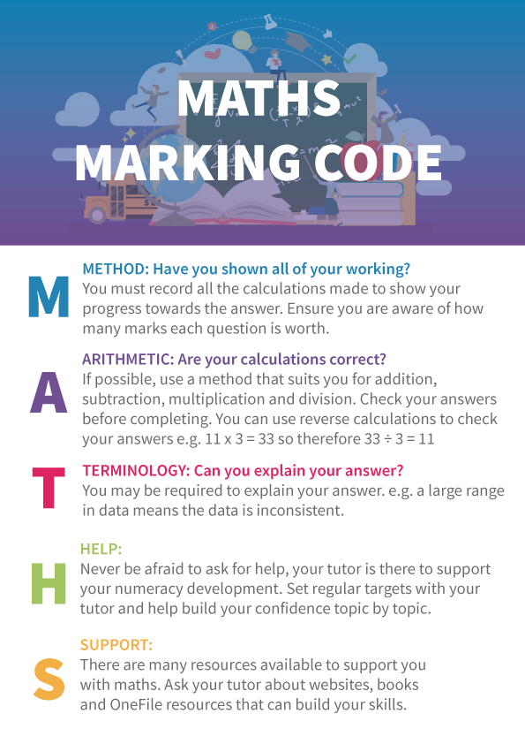

Fundamental British Values Key

Fundamental British Values are part of everyday life and are what makes us all individual and unique. It also takes into consideration how we interact in our communities and work environment. Throughout your study manual as you are undertaking tasks, look out for the symbols next to an activity this will be an opportunity to discuss life in modern Britain:

The rule of law

Mutual respect

Individual liberty

Democracy

Learner Plagiarism Guidance
What is plagiarism?
Plagiarism is the act of using someone else’s work or ideas as your own. If you try to pass someone else’s ideas/work off as yours when submitting work to your tutor, without acknowledging where you got the work from, you are committing plagiarism. Copying sentences or paragraphs from other sources, whether other students work or from other sources is simply not acceptable. This is defined as academic misconduct. Examples of other people’s work/sources could include language, thoughts, ideas, expressions and images.

How Back2work will deal with concerns relating to plagiarism.
If a tutor/IQA identifies a learner has committed plagiarism within the work, they have presented for marking the learner will be asked to amend the work. They will need to demonstrate the work is their own. Also, they will be given sufficient time (with a set target date) to redraft the work they have produced, ensuring if they are using research resources, they cite/reference where they have sourced the resources.

If a learner disputes the decision of the tutor/IQA this may be resolved in a meeting with the Lead IQA.

I confirm I have read the above guidance and am aware of the process I need to follow if the need should arise.
Learner Name
Signature
Date

Appeals Procedure for Learners
This procedure applies to all competency-based qualifications and units of qualifications. If a learner is dissatisfied with an exam/test result, they will need to follow the Appeals Procedure.
If learners are dissatisfied with an assessment outcome, they have the right to appeal. The main reasons for an appeal are likely to be:

- learners do not understand why they are not yet regarded as competent, because of unsatisfactory feedback from the Skills Coach/Trainer.
- learners believe they are competent, and that the Skills Coach/Trainer has misjudged them, or has failed to utilise some vital evidence.

Awarding Bodies expect most appeals from learners to be resolved within the centre.
Appeal to centre
If learners have received a decision as to their competence with which they are dissatisfied, they have the right to appeal directly to the Skills Coach or Trainer who carried out the assessment. This appeal must be in writing and clearly indicate:
- the points of disagreement
- the evidence in the portfolio that the learner believes meets the requirements of the Performance Criteria and/or knowledge for claiming competence.

The Skills Coach/Trainer must give a clear judgement, in writing, to the learner within 10 working days stating justification for the decision. If learners are not satisfied with the outcome, they can next appeal to the Internal Quality Assurer (IQA) within 5 working days. This appeal must be in writing but need not repeat the detail provided to the Skills Coach. The original written appeal to the Skills Coach/Trainer, and the Skills Coach’s judgement, must be made available to the IQA.

The IQA/Assurer must give a clear judgement, in writing to the learner within 10 working days stating justification for the decision.

If the IQA is not able to satisfy the situation and the leaner is still not happy with the decision, then there is a further opportunity to escalate this to the Lead IQA who will liaise with the Director of Quality & Performance. Should the learner be unhappy with the decision of the Director of Quality & Performance they may directly appeal to the Qualifications Regulator.

Regulated policies and procedures: Complaints Procedure, Internal Verification and Assessment Policy, Marking Policy, Quality Improvement Policy.

I confirm I have read the above procedure and am aware of the process I need to follow if the need should arise.
Learner Name
Signature
Date

